**AIM: CREATE** [**SOFTWARE REQUIREMENT SPECIFICATION**](https://www.google.com/search?rlz=1C1CHBF_enIN918IN918&sxsrf=AOaemvKzebkibwUijrKdP3UtA8v_dGA2iA:1642383699819&q=software+requirement+specification&spell=1&sa=X&ved=2ahUKEwi1tYyI1Lf1AhUUUGwGHWIKCnEQirwEKAB6BAgBEDI) **OF THE PROJECT**

**TOPIC: AI BASED SMART EXAM PROCTORING SYSTEM**

1. **INTRODUCTION:**
   1. **PURPOSE:**

The main reason for choosing this project is to make life easier of professors, colleges, students. System will save time and reduces human labour. System will conduct subject quizzes and provide a set of real time questions to students. Presently, human proctoring is the most common approach of evaluation, by either requiring the test taker to visit an examination centre, or by monitoring them visually and acoustically during exams via a webcam. However, such methods are labour intensive and costly. In this system, it performs automatic online exam proctoring. The system hardware includes webcam for the purpose of monitoring the visual and acoustic environment of the testing location. The system includes components that continuously estimate the key behaviour cues: active window detection, gaze estimation, and phone detection. By combining the continuous estimation components, we design higher level features to classify whether the test taker is cheating at any moment during the exam.

* 1. **DOCUMENT CONVENTIONS****:**

|  |  |
| --- | --- |
| DB | Database |
| DDB | Distributed Database |
| ER | Entity Relationship |

* 1. **INTENDED AUDIENCE AND READING SUGGESTIONS:**

The intended audience are colleges, schools, professors, private tutors, students, mass recruiters, organizations, etc. The rights of the colleges, professors, students will be different.

* 1. **PRODUCT SCOPE:**

The purpose of the AI Based Smart Exam Proctoring System is to make life easier of professors, colleges, students. System will save time and reduces human labour. The main purpose of the system is to detect whether the student is doing any malpractices at the time of online examination. Above all, we hope to provide a comfortable user experience along with the best pricing available.

* 1. **REFERENCES****:**

1. <https://ieeexplore.ieee.org/document/7828141>
2. <https://ieeexplore.ieee.org/document/9350872>
3. <https://ieeexplore.ieee.org/abstract/document/7845315>
4. **OVERALL DESCRIPTION:**
   1. **PRODUCT PERSPECTIVE:**

Massive open online courses and other forms of remote education continue to increase in popularity and reach. The ability to efficiently proctor remote online examinations is an important limiting factor to the scalability of this next stage in education. Presently, human proctoring is the most common approach of evaluation, by either requiring the test taker to visit an examination center, or by monitoring them visually and acoustically during exams via a webcam. However, such methods are labor intensive and costly. In this paper, we present a multimedia analytics system that performs automatic online exam proctoring. The system hardware includes one webcam, one wearcam, and a microphone for the purpose of monitoring the visual and acoustic environment of the testing location. The system includes six basic components that continuously estimate the key behavior cues: user verification, text detection, voice detection, active window detection, gaze estimation, and phone detection. By combining the continuous estimation components, and applying a temporal sliding window, we design higher level features to classify whether the test taker is cheating at any moment during the exam. To evaluate our proposed system, we collect multimedia (audio and visual) data from the students and performing various types of cheating while taking online exams. Extensive experimental results demonstrate the accuracy, robustness, and efficiency of our online exam proctoring system.

* 1. **PRODUCT FUNCTIONS:**

The product has following functions such as: Professor can monitor the student’s activities at the time of the exam and after the exam, Embedding a calculator for mathematics related examination, System will detect the phone if student is using in within the examination and it will log into database, Taking screenshots of the student face movements and storing inside the database, Monitoring Students face movements like moving up, down, left, right, etc and storing in database for further reference, System will disable the copy paste function in the exam and also it monitors when user tries to change the browser tab, opening other applications, Professor can Create, Update, View, Delete questions of the examination test, view results, Students can Give exam, check history, check results of the examination, In examination, student can bookmark the question, student can view only one question at a time on screen and system will give randomize questions, Authentication on Both side Student and Professor with face recognition [Login, Register, Forget Password, Change Password, Exam Login, Logout]

* 1. **USER CLASSES AND CHARACTERISTICS:**

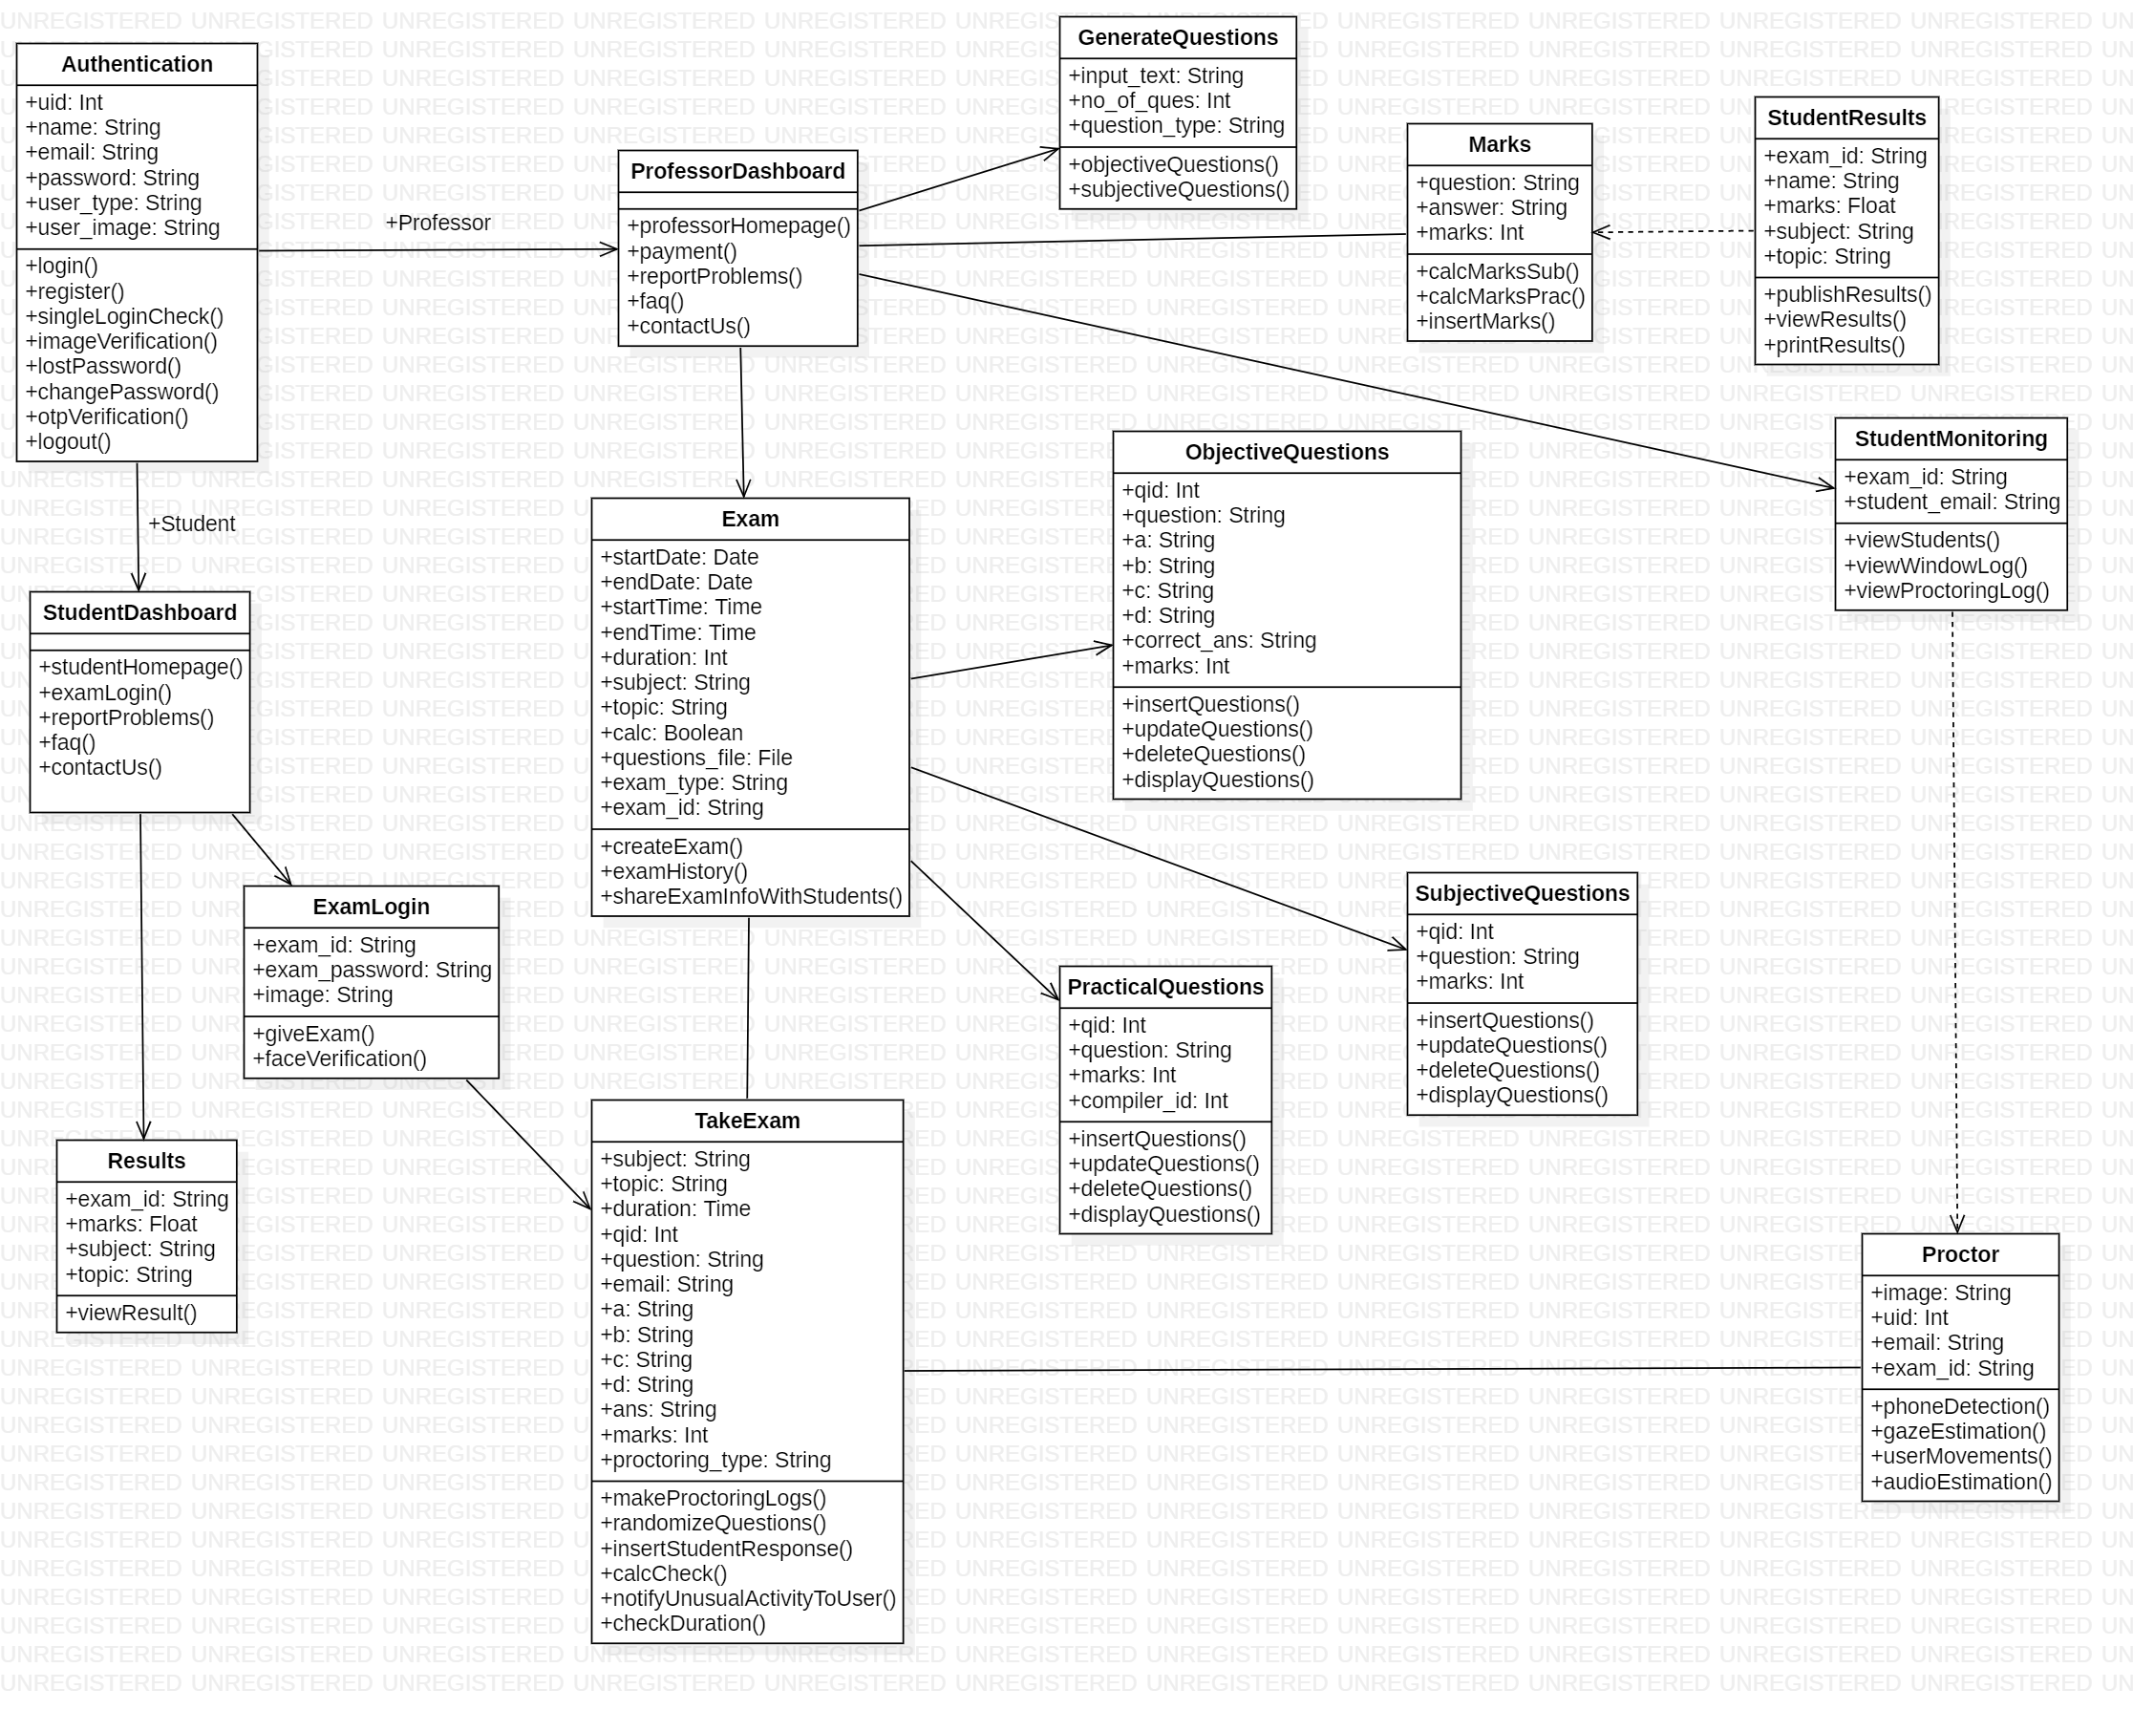

1. **Authentication:**

This class contains functions which are responsible for authentication of the user such as login, register, face verification, logout, etc

1. **ObjectiveQuestions:**

This class contains functions which are responsible for crud operations of generating objective type of questions.

1. **SubjectiveQuestions:**

This class contains functions which are responsible for crud operations of generating subjective type of questions.

1. **PracticalQuestions:**

This class contains functions which are responsible for crud operations of generating practical type of questions.

1. **GenerateQuestions:**

This class contains functions which are responsible for generating ai based automated questions answer such as objective and subjective.

1. **StudentsResults:**

This class contains functions which is responsible for generating results for the students.

1. **Exam:**

This class contains functions which is responsible for taking exam from the students.

1. **Proctor:**

This class contains functions which are detection of mobile phone, detection of more than 1 person, audio monitoring, window tab is changed, Screenshot recorder, etc

1. **StudentMonitoring:**

This class shows all the students logs of the proctoring to the professor, institute, college, school, etc

* 1. **OPERATING ENVIRONMENT:**

The operating environment requires for hardware is: Laptop or PC, i5 Processor Based Computer/ Laptop or higher, 8GB RAM, 50 GB Hard Disk, Web Camera and the operating environment requires for software is: Windows 7 or higher, Python 3.6.8, MySQL 5.5.5, Html, CSS, Bootstrap 4, Javascript, Jquery, Flask & Jinja2, IDE Used: Visual Studio Code

* 1. **ASSUMPTIONS AND DEPENDENCIES:**

1. **STRIPE:**

The system is depended on the stripe payment services for finance related

services.

1. **Sphere Engine:**

The system is depended on the sphere engine api which provides various 20+ compilers and interpreters which help our system to conduct the coding based practical exams.

1. **Vonage communication services:**

The system is depended on the vonage communication services which helps our system to conduct the live monitoring examination.

* 1. **COMMUNICATIONS INTERFACES:**

1. MYSQL
2. FLASK SERVER
3. ECOWEB EMAIL SERVER
4. **EXTERNAL INTERFACE REQUIREMENTS**
   1. **HARDWARE INTERFACES****:**
5. i5 Processor Based Computer/ Laptop or higher
6. 8GB RAM
7. 50 GB Hard Disk
8. Web Camera
   1. **SOFTWARE INTERFACES:**
9. Windows 7 or higher
10. Python 3.6.8
11. MySQL 5.5.5
12. Html, CSS, Bootstrap 4, Javascript, Jquery
13. Flask & Jinja2
14. IDE Used: Visual Studio Code
15. **SYSTEM FEATURES:**

1. **Real time monitoring of students:** Professor can monitor the student’s activities at the time of the exam and after the exam.
2. **Embedding calculator:** Embedding a calculator for mathematics related examination.
3. **Phone Detection:** System will detect the phone if student is using in within the examination and it will log into database.
4. **Student Movements:** Taking screenshots of the student face movements and storing inside the database.
5. **Gaze Estimation:** Monitoring Students face movements like moving up, down, left, right, etc and storing in database for further reference.
6. **Exam Window Monitoring:** System will disable the copy paste function in the exam and also it monitors when user tries to change the browser tab, opening other applications.
7. **Professor-Dashboard:** Create, Update, View, Delete questions of the examination test, view results.
8. **Student-Dashboard:** Give exam, check history, check results of the examination.
9. **Exam:** In examination, student can bookmark the question, student can view only one question at a time on screen and system will give randomize questions.
10. **Basic Authentication**: Authentication on Both side Student and Professor [Login, Register, Forget Password, Change Password, Exam Login, Logout]
11. **OTHER NONFUNCTIONAL REQUIREMENTS:**
    1. **PERFORMANCE REQUIREMENTS:**

The system must be interactive and the delays involved must be less. So in every action-response of the system, there are no immediate delays. In case of opening windows forms, of popping error messages and saving the settings or sessions there is delay much below 2 seconds, In case of opening databases, sorting questions and evaluation there are no delays and the operation is performed in less than 2 seconds for opening, sorting, computing, posting > 95% of the files. Also when connecting to the server the delay is based editing on the distance of the 2 systems and the configuration between them so there is high probability that there will be or not a successful connection in less than 20 seconds for sake of good communication.

* 1. **SAFETY REQUIREMENTS****:**

If there is extensive damage to a wide portion of the database due to catastrophic failure, such as a disk crash, the recovery method restores a past copy of the database that was backed up to archival storage (typically tape) and reconstructs a more current state by reapplying or redoing the operations of committed transactions from the backed-up log, up to the time of failure.

* 1. **SECURITY REQUIREMENTS:**

Security systems need database storage just like many other applications. However, the special requirements of the security market mean that vendors must choose their database partner carefully.

* 1. **SOFTWARE QUALITY ATTRIBUTES:**

1. **Availability:**

If the internet service gets disrupted while sending information to the server, the information can be send again for verification.

1. **Security:**

The main security concern is for users account hence proper login mechanism should be used to avoid hacking. Hence, security is provided from use of face recognition technology.

1. **Usability:**

As the system is easy to handle and navigates in the most expected way with no delays. In that case the system program reacts accordingly and transverses quickly between its states.

1. **Correctness:**

The system will provide correct information about students, professors, exams, proctoring logs, exam results, etc

* 1. **BUSINESS RULES:**

The business rules of this system are:

1. Validating email address of the student and professor with otp.
2. Validating face of the student and professor with face recognition technology.